**Movie Booking Application**

-By **Sabarish** **Iyer**

Contents

Summary 4

GitHub 4

Business requirements covered 5

System Architecture 5

Micro Services List 5

Eureka Server - Dashboard 5

Primary Flow of Admin Creating A Movie 6

Entities 6

Movie Entity: 6

Movie And Theatre Entity: 6

Data Transfer Object (DTO) 7

Movie DTO: 7

Movie Controller 8

Create Movie Interface: 8

Create Movie Method Implementation: 8

Movie Service 9

Add Movie Method Implementation: 9

Movie Repository 9

Exception Created for Similar Movie Check Details 10

API Gateway Property to pass all Movies related URLs to Movie Module 10

Postman Screenshots for Add Movie 10

Admin Adding Movie: 10

Admin Adding Movie with incomplete Information: 11

User trying to Add Movie: 11

Swagger Screenshots for Add Movie 12

Postman Screenshots for other Endpoints 14

Registering New User 14

Register Validation Check 14

Login User 15

Login User with wrong Password: 15

Forgot password Check: 16

Password Reset: 16

All Movies 17

Movie Search 17

Book Ticket for Movie 18

Get All Tickets for Movie 18

Movie Status Change: 19

Invalid Movie Tickets Update 20

Delete Movie 21

Delete Movie by User 21

Caching and session management 22

Caching Implemented 22

Session Management 22

Swagger 23

Swagger - User: 23

Swagger - Movies: 23

Swagger - Tickets: 24

Exception - Custom & Handling 25

Exception User Already Exists: 25

Custom Exception Super Class for all Custom Exceptions: 25

Global Exception Handler 25

Postman Showing Custom Exception 26

Testing 27

Service Test of Get By ID 27

Controller Test of View All: 28

Maven Test: 29

Code Quality and Coverage 29

Sonar Qube: 29

Front-End Screenshots 30

Home Page 30

Register 30

Register Validation 31

Login Page 31

Homepage for Logged-In User 32

Movie Booking Page 32

Updated Home Page 33

My Bookings 33

Forgot Password 34

Forgot Password Check for Old Password 34

Admin Home Page: 35

Update Options 36

Movie Deletion 37

New Movie Creation 37

Button to Reset Movie Status 38

# Summary

This project implements a Movie Ticket Booking System using a microservices architecture. The application is composed of five independently deployable modules: User Module (authentication and authorization), Movie Module (movie and theatre management), Tickets Module (ticket booking and order management), API Gateway (centralized routing and security), and Eureka Server (service discovery).

The system supports role-based access control using JWT-based stateless authentication. End users can register, log in, search and view movies, and book tickets, while administrators can manage movies and monitor booking status. All APIs are documented using Swagger / Java Docs, validated using Bean Validation, and protected using Spring Security.

The application follows clean separation of concerns using controller interfaces for API contracts and controller implementations for execution logic. Business logic resides in service layers with centralized exception handling and optional caching for improved performance.

The frontend is built using Angular (standalone architecture) and communicates with backend services through the API Gateway. Unit tests, Maven build reports, and static code analysis demonstrate code quality and maintainability.

This project satisfies the required business use cases while maintaining extensibility for future enhancements.

## GitHub

Backend:

* Link: <https://github.com/Sabarish-2/BookAMovie-Spring-Boot>
* To run

mvn clean package

java -jar target/*.jar

Frontend:

* Link: <https://github.com/Sabarish-2/MovieBookingApp_Angular>
* To run

npm install

npm run build

# Business requirements covered

* User Registration and Login with Role-based access (Admin / Customer)
* View and Search Movies by name and theatre
* Book Tickets for a selected Movie and theatre
* Persist booked tickets and allow users to view their bookings
* Admin management of Movies (Add / Delete) and its status updates
* Centralized API routing and Security handled by API Gateway
* Exception Handling and Security
* Swagger and Java Documentation

# System Architecture

## Micro Services List

1. Movie And Theatre Module - Handles All Movies Data and Movie CRUD Operation.
2. Tickets Module - Handles All Tickets and Ticket Booking Mechanism.
3. User Module - Handles Login, Register and Forgot Password Mechanism.
4. API Gateway - Routes All Requests to respective Micro-service.
5. Eureka Server - Stores and gives an instance of required Micro-service from load-balancer.

## Eureka Server - Dashboard

# Primary Flow of Admin Creating A Movie

## Entities

### Movie Entity:

@Entity

@Data

@NoArgsConstructor

@AllArgsConstructor

public class Movie {

@EmbeddedId

private MovieAndTheater movieAndTheatre;

@Min(1)

@Column(nullable = false)

private int ticketsAllotted;

@Enumerated(EnumType.STRING)

private MovieStatus adminOverrideStatus;

public Movie(MovieAndTheater movieAndTheatre, int ticketsAllotted) {

this.ticketsAllotted = ticketsAllotted;

this.movieAndTheatre = movieAndTheatre;

}

}

### Movie And Theatre Entity:

* Composite Key Requires Embeddable class

@Data

@AllArgsConstructor

@NoArgsConstructor

@Embeddable

public class MovieAndTheater {

@NonNull

private String movieName;

@NonNull

private String theatreName;

}

## Data Transfer Object (DTO)

### Movie DTO:

@Data

@NoArgsConstructor

@AllArgsConstructor

public class MovieDTO {

@NotBlank(message = "{com.moviebookingapp.movie_and_theatre_module.dtos.movieName.invalid}")

private String movieName;

@NotBlank(message = "{com.moviebookingapp.movie_and_theatre_module.dtos.theatreName.invalid}")

private String theatreName;

@Min(value = 1L, message = "{com.moviebookingapp.movie_and_theatre_module.dtos.ticketsAllotted.invalid}")

private int ticketsAllotted;

private Integer ticketsAvailable;

private MovieStatus movieStatus;

public MovieDTO(String movieName, String theatreName, int ticketsAllotted) {

this.movieName = movieName;

this.theatreName = theatreName;

this.ticketsAllotted = ticketsAllotted;

}

## Movie Controller

### Create Movie Interface:

@Operation(summary = "Create A New Movie")

@ApiResponse(responseCode = "201", description = "Movie Created Successfully")

@ApiResponse(responseCode = "400", description = "Validation Error in Movie Details Provided")

@ApiResponse(responseCode = "409", description = "Movie Already Exists")

ResponseEntity<MovieDTO> createMovie(@Valid @RequestBody MovieDTO movieDTO);

### Create Movie Method Implementation:

/**

* Creates a new movie.

*

* @param movieDTO The movie details to create.

* @return A response entity containing the created movie.

*/

@Override

@PostMapping("create")

@PreAuthorize("hasRole('ADMIN')")

public ResponseEntity<MovieDTO> createMovie(MovieDTO movieDTO) {

return new ResponseEntity<>(movieService.addMovie(movieDTO), HttpStatus.CREATED);

}

## Movie Service

### Add Movie Method Implementation:

/**

* Adds a new movie to the system.

*

* @param movieDTO Data transfer object containing movie details.

* @return The added movie as a DTO.

* @throws MovieAlreadyExistsException if the movie already exists.

*/

@Override

public MovieDTO addMovie(MovieDTO movieDTO) {

Movie newMovie = mapper.map(movieDTO);

if (movieRepository.findById(newMovie.getMovieAndTheatre()).isPresent()) {

throw new MovieAlreadyExistsException(

"Movie " + movieDTO.getMovieName() + " at " + movieDTO.getTheatreName() + " Already Exists!");

}

Movie savedMovie = movieRepository.save(newMovie);

return mapper.map(savedMovie);

}

## Movie Repository

@Repository

public interface MovieRepository extends JpaRepository<Movie, MovieAndTheater>, JpaSpecificationExecutor<Movie> {

}

## Exception Created for Similar Movie Check Details

public class MovieAlreadyExistsException extends CustomException {

@Serial

private static final long serialVersionUID = 9L;

public MovieAlreadyExistsException(String message) {

super(serialVersionUID, HttpStatus.CONFLICT, message);

}

}

## API Gateway Property to pass all Movies related URLs to Movie Module

- id: movie-and-theatre-module

uri: lb://MOVIE-AND-THEATRE-MODULE

predicates:

- Path=/api/v1.0/moviebooking/movies/**

## Postman Screenshots for Add Movie

### Admin Adding Movie:

### Admin Adding Movie with incomplete Information:

### User trying to Add Movie:

## Swagger Screenshots for Add Movie

# Postman Screenshots for other Endpoints

## Registering New User

### Register Validation Check

## Login User

### Login User with wrong Password:

## Forgot password Check:

### Password Reset:

## All Movies

## Movie Search

## Book Ticket for Movie

## Get All Tickets for Movie

## Movie Status Change:

### Invalid Movie Tickets Update

## Delete Movie

### Delete Movie by User

# Caching and session management

## Caching Implemented

* Tickets cannot be modified, hence can be cached for better performance.

/**

* Retrieves a ticket by its ID.

*

* @param ticketID The ID of the ticket to retrieve.

* @return The ticket as a DTO.

* @throws TicketNotFoundException if the ticket is not found.

*/

@Override

@Cacheable("ticket")

public TicketDTO getTicketByID(Long ticketID) {

Ticket ticket = ticketRepository.findById(ticketID)

.orElseThrow(() -> new TicketNotFoundException(ticketID));

return mapper.map(ticket);

}

## Session Management

* Stateless Session Tokens are used in security.

httpSecurity

.csrf(AbstractHttpConfigurer::disable)

.authorizeHttpRequests(auth -> auth

.requestMatchers("/swagger-ui/**", "/swagger-ui.html", "/v3/api-docs/**").permitAll()

.requestMatchers(HttpMethod.GET, "/tickets/booked/**").permitAll()

.anyRequest().authenticated()

)

.sessionManagement(session -> session.sessionCreationPolicy(SessionCreationPolicy.STATELESS));

# Swagger

### Swagger - User:

### Swagger - Movies:

### Swagger - Tickets:

# Exception - Custom & Handling

Exception User Already Exists:public class UserAlreadyExistsException extends CustomException {  
  
 @Serial  
 private static final long serialVersionUID = 9L;  
  
 public UserAlreadyExistsException(String message) {  
 super(serialVersionUID, HttpStatus.CONFLICT, message);  
 }  
}

### Custom Exception Super Class for all Custom Exceptions:

@Getter

public abstract class CustomException extends RuntimeException {

private final long serialVersionUIDPerException;

private final HttpStatus status;

private final String message;

protected CustomException(long serialVersionUIDPerException, HttpStatus status, String message) {

this.serialVersionUIDPerException = serialVersionUIDPerException;

this.status = status;

this.message = message;

}

}

### Global Exception Handler

* To handle all Exceptions and show Logs instead of throwing errors

// Handle Custom Errors

@ExceptionHandler(CustomException.class)

public ResponseEntity<String> handleCustomExceptions(CustomException ex) {

return new ResponseEntity<>(ex.getMessage(), ex.getStatus());

}

// Handle All other Errors

@ExceptionHandler(Exception.class)

@ResponseStatus(HttpStatus.INTERNAL_SERVER_ERROR)

public String handleOtherExceptions(Exception ex) {

return "Exact Error in Movie: " + ex;

}

### Postman Showing Custom Exception

# Testing

### Service Test of Get By ID

@Test

@DisplayName("GetMovieByID-Positive")

void test_GetMovieByID_positive() {

when(movieRepository.findById(movieAndTheater)).thenReturn(Optional.of(movie));

when(mapper.map(movie)).thenReturn(movieDTO);

when(ticketsClient.getBookedTickets(any(), any())).thenReturn(ResponseEntity.ok(1L));

MovieDTO actualMovie = movieService.getMovieByID(movieName, theatreName);

assertEquals(movieDTO, actualMovie);

}

@Test

@DisplayName("GetMovieByID-Negative-MovieNotFound")

void test_GetMovieByID_negative_movieNotFound() {

when(movieRepository.findById(movieAndTheater)).thenReturn(Optional.empty());

assertThrows(MovieNotFoundException.class, () -> movieService.getMovieByID(movieName, theatreName));

}

@Test

@DisplayName("GetMovieByID-Negative-FeignRuntimeInPrivateMethod")

void test_GetMovieByID_negative_feignRuntimeInPrivateMethod() {

when(movieRepository.findById(movieAndTheater)).thenReturn(Optional.of(movie));

when(mapper.map(movie)).thenReturn(movieDTO);

when(ticketsClient.getBookedTickets(movieName, theatreName)).thenReturn(null);

assertThrows(RuntimeException.class, () -> movieService.getMovieByID(movieName, theatreName));

}

### Controller Test of View All:

@Test

@DisplayName("ViewAllMovies-Positive")

void viewAllMovies_positive() {

when(movieService.getAllMovies()).thenReturn(List.of(movieDTO));

ResponseEntity<List<MovieDTO>> response = movieController.viewAllMovies();

assertEquals(HttpStatus.OK, response.getStatusCode());

assertEquals(List.of(movieDTO), response.getBody());

}

@Test

@DisplayName("ViewAllMovies-Negative-MovieNotFound")

void viewAllMovies_negative_movieNotFound() {

when(movieService.getAllMovies()).thenThrow(new MovieNotFoundException());

assertThrows(MovieNotFoundException.class, () -> movieController.viewAllMovies());

}

### Maven Test:

## Code Quality and Coverage

### Sonar Qube:

# Front-End Screenshots

### Home Page

### Register

### Register Validation

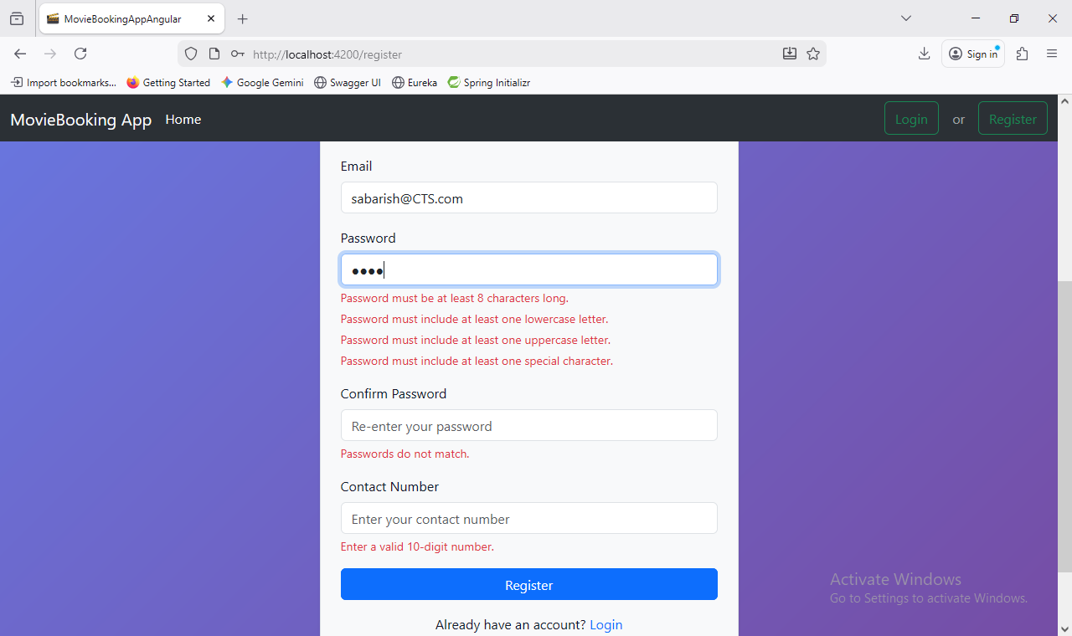

### Login Page

### Homepage for Logged-In User

### Movie Booking Page

### Updated Home Page

### My Bookings

### Forgot Password

### Forgot Password Check for Old Password

### Admin Home Page:

### Update Options

### Movie Deletion

### New Movie Creation

### Button to Reset Movie Status

